**DAILY ONLINE ACTIVITIES SUMMARY**

|  |  |  |  |  |
| --- | --- | --- | --- | --- |
| **Date:** | | **05-06-2020** | **Name:** | **Latika Kavoor** |
| **Sem & Sec** | | **4th Sem & A-Section** | **USN:** | **4AL18CS035** |
| **Online Test Summary** | | | | |
| **Subject** | **-** | | | |
| **Max. Marks** | **-** | | **Score** | **-** |
| **Certification Course Summary** | | | | |
| **Course** | | **STEP-The Hindu** | | |
| **Certificate Provider** | | **THE HINDU** | **Duration** | **10 hrs** |
| **Coding Challenges** | | | | |
| **Problem Statement:**write a java program to read three integer values from the keyboard and find the sum of the values. Declare a variable "sum" of type int and store the result in it. | | | | |
| **Status: Completed** | | | | |
| **Uploaded the report in Github** | | | **Yes** | |
| **If yes Repository name** | | | <https://github.com/alvas-education-foundation/latika.kavoor/tree/master/coding_solutions> | |
| **Uploaded the report in slack** | | | **Yes** | |

Online Test Details: (Attach the snapshot and briefly write the report for the same)

NO TEST CONDUCTED

Certification Course Details: (Attach the snapshot and briefly write the report for the same)

I started with STEP-THE HINDU course. It is a course provided by ICT ACADEMY and THE HINDU. It is a course to improve your communication skill. There are LISTENING,READING,WRITING,SPEAKING,GRAMMAR,VOCABULARY modules in it.I am currently doing the week 2 course.

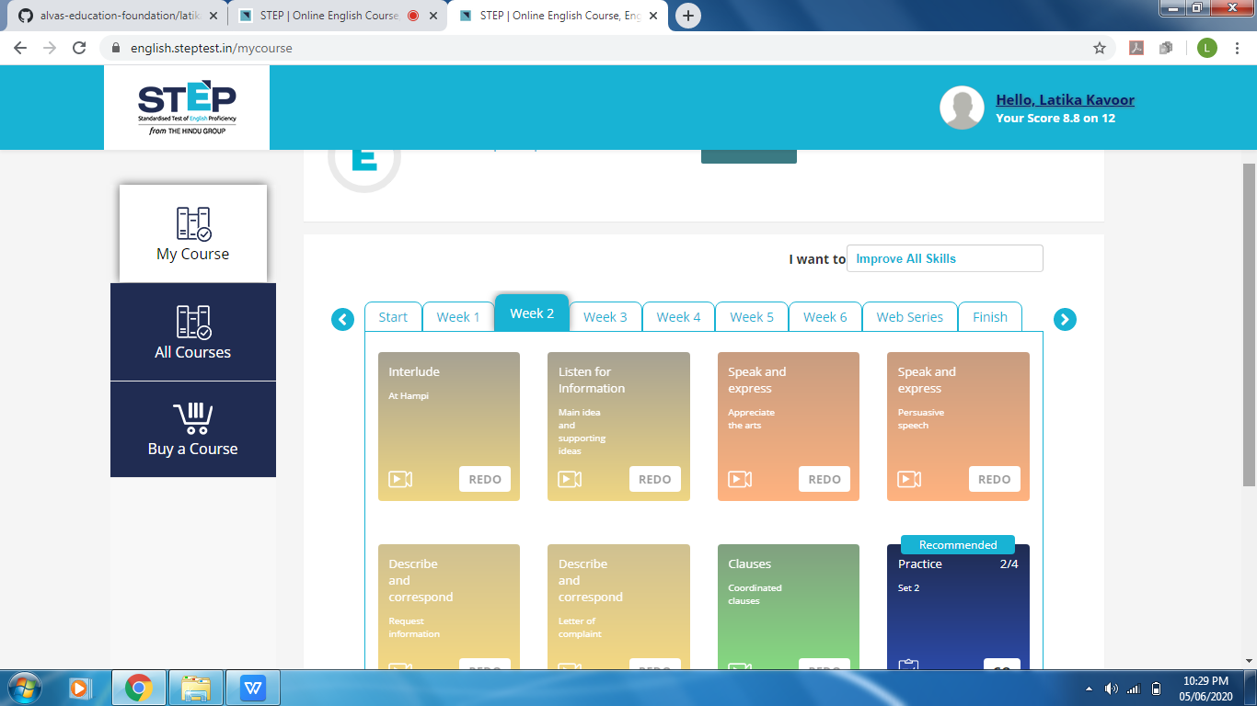

Coding Challenges Details: (Attach the snapshot and briefly write the report for the same)

Solved the problem and uploaded the same on github

